Kent Stringer

Dylan Shoupe

Dylan Terry

**Design**

UML:

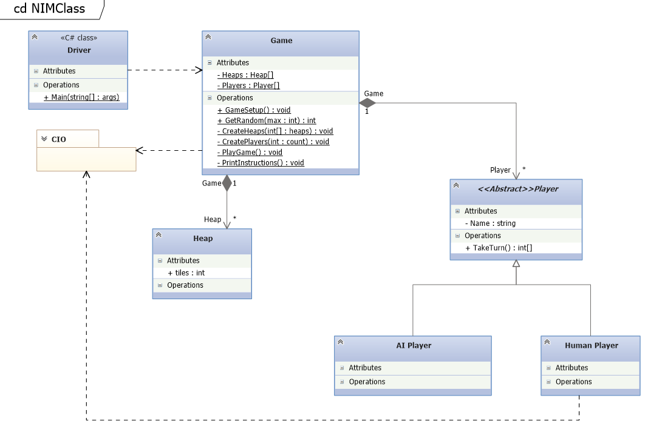

Flow Diagrams:

* Nim Full 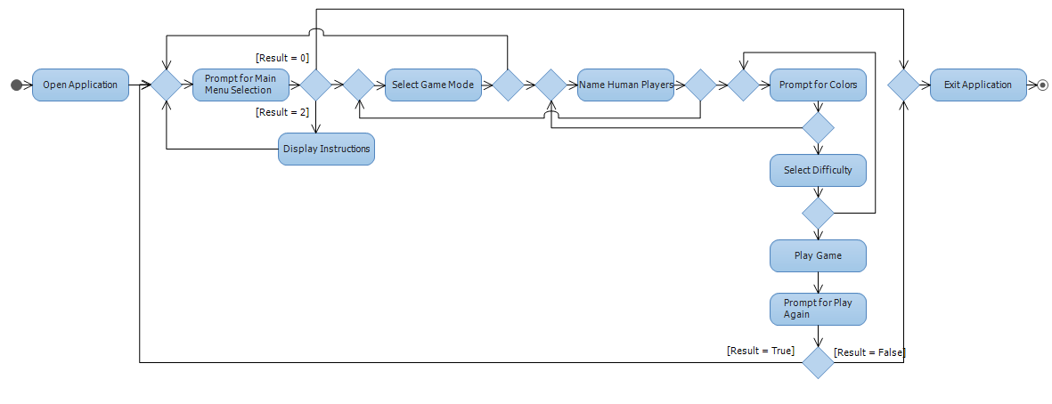
* Nim Human Player 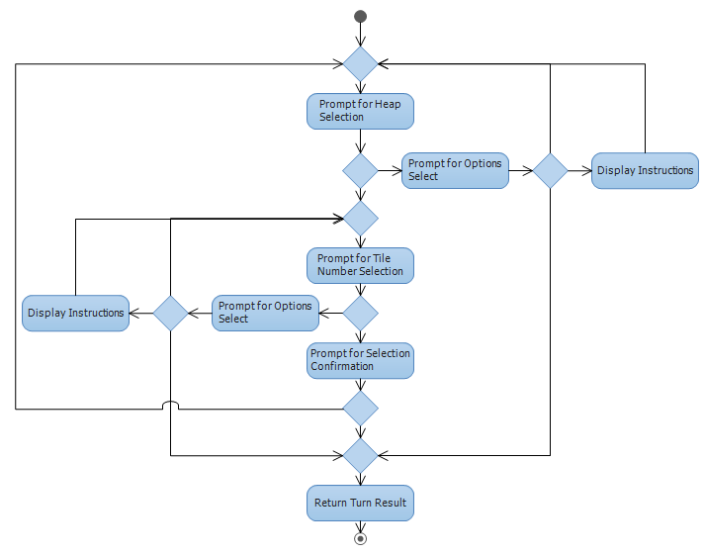
* Nim AI Turn 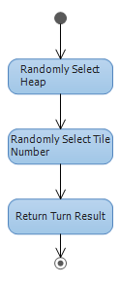
* Play Game 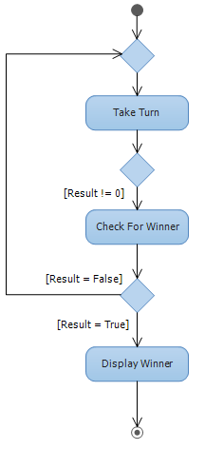
* Use Case 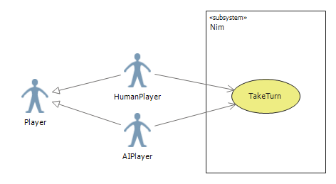

Developer Docs:

* Classes
  + Driver
    - Will call GameSetup()
  + Game
    - Players : Player[2]
      * Class level variable that will hold two instances of Player
    - Heaps : Heap[]
      * Class level variable that will be of variable size based on the difficulty chosen by the player
      * Easy = 2, Medium = 3, Hard = 4
    - GameSetup() : void
      * Will have a do, while loop that loops until the user decides to exit the game
        + Will use C# library “CIO” to prompt the user for a menu selection

First menu will ask the user if they want to Start the game, see the instructions, or quit

Second menu will ask the user if they wish to play against a computer or another human player, see the instructions, go back, or quit

The Third menu will ask the user to choose a difficulty, see instruction, go back, or quit

Once the user has chosen a difficulty the createHeaps() method will be called and will be passed an int array based on the choice of the user. Easy {3,3}, Medium {2,5,7}, and Hard {2,3,8,9}

* + - * + Will call CreatePlayers() then will call PlayGame()
        + After PlayGame() has completed the user will be asked if they wish to play again. If the answer is no, the loop will end and the program will close. If yes, the loop will continue from the beginning.
    - PlayGame() : void
      * Int playerTurn will be determined by calling GetRandom(10)
      * Players array will use playerTurn mod 2 as the index value to determine turn order and the active player.
      * Will have a do, while loop that will continue until the end of the game or until the user has chosen to exit the game in mid game.
        + Inside the loop the takeTurn() will be called from the Players[] utilizing playerTurn % 2.
        + After takeTurn() completes, If all heaps added together equal 0 the loop will end with the opposite player being declared the victor. If it does not equal 0 the playTurn variable will be incremented by 1.
        + This loop will continue until all heaps added together equal 0 or the user opts to return to the main menu
    - CreatePlayers(int count) : void
      * Parameter “count” will determine the number of human players that will be created.
      * Given 1 human player the method will generate 1 AI player.
      * Each human player will be asked to provide their name
        + A default name will be given in the case of a NULL value
      * No more than 2 players can be created in a single game
    - CreateHeaps(int[] heaps) : void
      * Parameter “heaps” will be an array of int that will be utilized for to fill the class level variable Heap[] with the appropriate number of heaps and the correct number of tiles per heap.
        + Using initialization syntax, Heap[] will be created using the integers provided by the parameter “heaps” to create a new Heap instance passing in the int value for the tile amount of that Heap.
    - PrintInstructions() : void
      * Method will use console.writeline() to print out the instructions of the game
      * This method must be available during any player turn, during the game, and before starting any new game
    - GetRandom(int max): int
      * Will generate a number between 1 and the max value given
      * This method will be used to determine the turn order
      * This method will be used by the AI class to randomly choose a heap and a value to be taken.
* Models
  + Abstract Player Class
    - PlayerName : string
      * Property Value
    - TakeTurn() : int[]
      * Will be implemented by Human and AI class
  + Human Model (inherits parent player class)
    - TakeTurn(): int[] – Implemented from the Player class
      * Use C# Library “CIO” to get two int values from the user.
        + First value will the heap number
        + Second will be the number of tiles they wish to remove
      * This prompt will loop until the user has given valid input for both ints
      * Method will return an int array containing their heap choice and the number of tiles to be removed (choices{1,7})
  + AI Model (inherits parent player class)
    - TakeTurn(): int[] - Implemented from the Player class
      * Will call GetRandom() passing in the number of heaps
        + The number returned from GetRandom() will be validated to ensure the heap has any remaining tiles
        + This method will be called until a valid heap has been chosen
      * Will call GetRandom() passing in the number of tiles left in the chosen heap
      * Method will return an int array containing their heap choice and the number of tiles to be removed (choices{1,7})
  + Heap Model
    - Int tiles
      * Property value will initially be set by the constructor

UI/UX Templating:

-----------------------------------

This is the frame for the main menu

~~~~~~~~~~~~~~~~~~~~~~~~~~~~~~~~~~~~~~~~~~~~~~~~~~~~~~~~~~~~~~~~~~~~~~~~~~~~~~~~~~~~~~~~~~~~~~~~~~~~~~~~~~~~~~~~~~~~~~~~~~~~

Welcome to the Game of Nim!

1. Start Game

2. Instructions

0. Quit

<- Option 1 ->

*Displays a new menu*

What Game mode would you like to play?

1. Human vs Human

2. Human vs AI

3. Instructions

4. Back

0. Quit

<- Option 2 ->

*Displays an instruction list on how to play nim*

How to play Nim:

*Instructions listed*

<- Option 0 ->

*Program exits with a goodbye message*

----------------------------------------

This is the frame for the game mode menu

~~~~~~~~~~~~~~~~~~~~~~~~~~~~~~~~~~~~~~~~~~~~~~~~~~~~~~~~~~~~~~~~~~~~~~~~~~~~~~~~~~~~~~~~~~~~~~~~~~~~~~~~~~~~~~~~~~~~~~~~~~~~

What Game mode would you like to play?

1. Human vs Human

2. Human vs AI

3. Instructions

4. Back

0. Quit

<- Option 1 ->

*Asks user for what the 2 player names are*

Enter player 1's name:

Enter player 2's name:

<- Option 2 ->

*Asks user what the human player's name will be*

Enter your player's name:

<- Option 3 ->

*Displays an instruction list on how to play nim*

How to play Nim:

*Instructions listed*

<- Option 4 ->

*Goes back to the prevoius menu*

<- Option 0 ->

*Program exits to main menu*

-----------------------------------------

This is the frame for the difficulty menu

~~~~~~~~~~~~~~~~~~~~~~~~~~~~~~~~~~~~~~~~~~~~~~~~~~~~~~~~~~~~~~~~~~~~~~~~~~~~~~~~~~~~~~~~~~~~~~~~~~~~~~~~~~~~~~~~~~~~~~~~~~~~

What Difficulty would you like to play on?

1. Easy (3,3)

2. Medium (2,5,7)

3. Hard (2,3,8,9)

4. Instructions

5. Back

0. Quit

<- Option 1 ->

*Game will be started with easy difficulty with 2 heaps, each having 3 sticks*

<- Option 2 ->

*Game will be started with easy difficulty with 3 heaps, with 2, 5, 7 sticks respectively*

<- Option 3 ->

*Game will be started with easy difficulty with 4 heaps, with 2, 3, 8, 9 sticks respectively*

<- Option 4 ->

*Displays an instruction list on how to play nim*

How to play Nim:

*Instructions listed*

<- Option 5 ->

*Goes back to the prevoius menu*

<- Option 0 ->

*Program exits to main menu*

------------------------------------------

This is the frame for the player turn menu

~~~~~~~~~~~~~~~~~~~~~~~~~~~~~~~~~~~~~~~~~~~~~~~~~~~~~~~~~~~~~~~~~~~~~~~~~~~~~~~~~~~~~~~~~~~~~~~~~~~~~~~~~~~~~~~~~~~~~~~~~~~~

What would you like to do?

1. Take Turn

2. Instructions

0. Quit

<- Option 1 ->

*Goes to take turn prompts*

<- Option 2 ->

*Displays an instruction list on how to play nim*

How to play Nim:

*Instructions listed*

<- Option 0 ->

*Program exits to main menu*

---------------------------------------------

This is the frame for the player turn prompts

~~~~~~~~~~~~~~~~~~~~~~~~~~~~~~~~~~~~~~~~~~~~~~~~~~~~~~~~~~~~~~~~~~~~~~~~~~~~~~~~~~~~~~~~~~~~~~~~~~~~~~~~~~~~~~~~~~~~~~~~~~~~

*Display heaps*

Heap 1 ...

Heap 2 ...

Enter what heap you would like to take from:

How many from that heap:

*This will loop until a winner is decided*

------------------------------------

This is the frame for winner display

~~~~~~~~~~~~~~~~~~~~~~~~~~~~~~~~~~~~~~~~~~~~~~~~~~~~~~~~~~~~~~~~~~~~~~~~~~~~~~~~~~~~~~~~~~~~~~~~~~~~~~~~~~~~~~~~~~~~~~~~~~~~

*Winner is displayed*

{PlayerName} Wins!!

----------------------------------------------------------

This is the frame for the user continue boolean expression

~~~~~~~~~~~~~~~~~~~~~~~~~~~~~~~~~~~~~~~~~~~~~~~~~~~~~~~~~~~~~~~~~~~~~~~~~~~~~~~~~~~~~~~~~~~~~~~~~~~~~~~~~~~~~~~~~~~~~~~~~~~~

Would you like to play again? (y/n)

<- Option y ->

*Main menu is displayed and the game starts over*

<- Option n ->

*Program exits with a goodbye message*